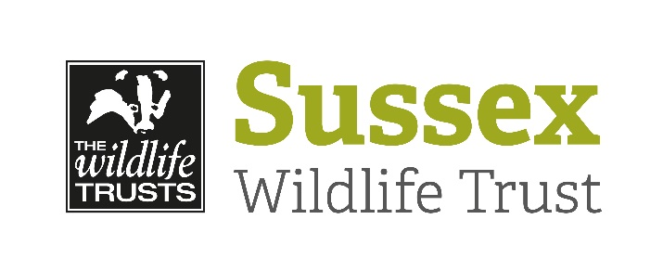
Wildlife Rangers (12 – 16)
PARENTAL CONSENT FORM

To the Parent or Guardian

Please complete this form and return to tamarajewell@sussexwt.org.uk or to Gatwick Greenspace Partnership, Unit 7, Tilgate Drive, Tilgate Park, Crawley, W. Sussex, RH10 5PQ.

PERSONAL DETAILS OF CHILD

Name……………………………………………………………………………………………………………

Date of Birth………………………………………………………………………………………..….……...

Contact address and telephone numbers for parents/guardians

Name……………………………………………….. Name…………………..………………..…………

Address………………………………………..….. Address……………..……………….…..………

……………………………………………….……… ………………………….…………..……………..

……………………………………………………… ……………………………………………………..

Home Tel No:………………….…………………. Home Tel No:……………………….…….……..

Work Tel No:……………………………..………. Work Tel No:……………………….....………...

Mobile No:………………………………..……… Mobile No:…………………………………...…..

EMAIL ………………………………………………

Does your child have any illnesses, disabilities or allergies that may affect him/her when taking part in group activities? Yes/No

Does your child require the routine use of any medication? Yes/No

Does your child require a special diet? Yes/No

Is your child registered as Clinically Extremely Vulnerable by your Doctor? Yes/No
Are you shielding at home to protect a family member? Yes/No

If yes to any of these questions, please give details and appropriate instructions.
(Please note that if a child needs to take medication during an event this will need to
be self-administered.)

………………………………………………………………………………………………………..…………

………………………………………………………………………………………………..…………………

Name of child’s doctor…………………………………………………………………..………………….

Address………………………………………………………………………………………..………………

…………………………………………………………..Tel No:……………………………………………...

Date of last anti-tetanus injection………………………………………………..………………………
Participants will be asked to verbally to confirm the following on arrival:
I confirm that I have not within the last 14 days;
Tested positive or am presumptively positive with the Coronavirus or been identified as a potential carrier.
Experienced any symptoms commonly associated with the Coronavirus.
Been in any location designated as a risk by the Government or Public Health England.
Been in direct contact with or in the immediate vicinity of any person been identified as a carrier or potential carrier of the
Coronavirus.

Please tick to confirm and agree the following in event of Coronavirus symptoms occurring during &/or 7 days after the session:

If your child develops any of the symptoms associated with COVID-19 during the session, we will inform you and you will need to arrange immediate collection of your child.
Once home, you will need to arrange to have a test to see if you have developed COVID-19 – visit NHS.UK to arrange or contact NHS 119 via telephone if you do not have internet access. The same is applicable if symptoms appear in the 7 days after the event.
https://self-referral.test-for-coronavirus.service.gov.uk/antigen/name

PUBLICITY

The Sussex Wildlife Trust carries out a range of exciting activities which are of interest both to our sponsors and to the general public. For this reason pictures may occasionally feature in either the local or national media, or in publications produced by The Wildlife Trusts, Wildlife Watch (the junior branch of the Wildlife Trusts), e.g. Watchword or local Trust magazines.

Please tick this box if you are happy for photographs of your child to be used in publicity and publications by Wildlife Watch and The Wildlife Trusts.

Please tick this box if you would prefer that your child’s photograph did not feature in any of our publicity or publications.

GOING HOME

I undertake to ensure that my child/children will be collected from the event by

(Name) ………………..…………………………………………………………………………………..

I am happy that my child travels home on his/her own.

If this should be different for any reason, I will inform the volunteer co-ordinator

AGREEMENT

I undertake that my child will be adequately and safely equipped and clothed for the activities planned. This includes a face mask, hand gel, waterproof clothing and footwear, sun cream, hat etc.
I accept that she/he may not be allowed to take part if the leader considers it unsafe.

In the event of illness or accident, I authorise the registered leader to sign on my behalf any written form of consent required by hospital authorities if the delay required to obtain my own signature is considered inadvisable by the doctor or surgeon concerned.

Signed (Parent / Guardian)………………………………………………………………………………..

Date……………………………………………………………………………..……………………………..

