SUSSEX WILDLIFE TRUST
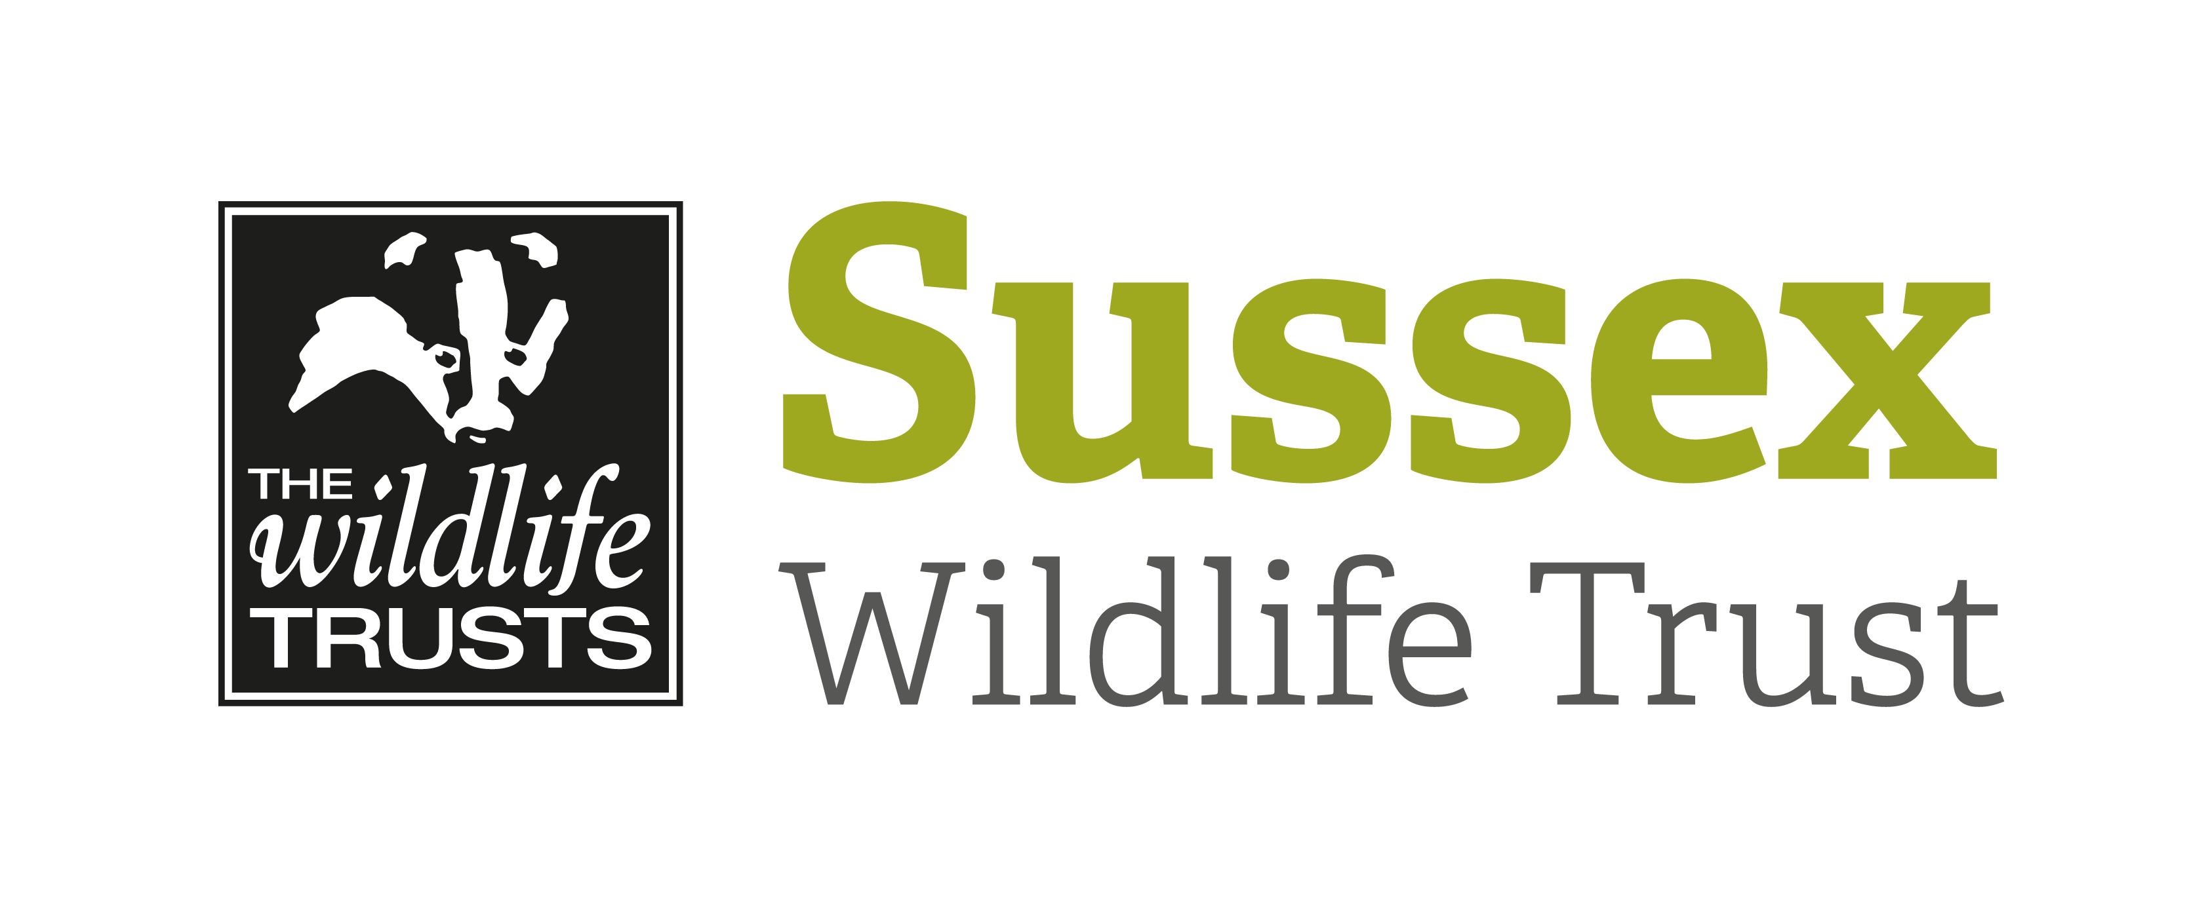

COURSE INFORMATION SHEET

Course Title: Underwater Photography for Seasearch |  |  | Day/Date/Year:  Saturday 14th May 2022
Start Time: 10am |  | Finish Time: 4pm
Course Tutor: | Matt Doggett
Course description and subjects covered | This course will provide an overview of the ‘how-to’s’ of underwater photography, specifically looking into the detail of taking good images for Seasearch / ecological purposes.  The course is aimed primarily at Seasearch divers / snorkelers, but is open to anyone who wishes to learn more about underwater photography.  The course is suitable for beginners to intermediate level. Having your own underwater camera set up is useful but not essential.
Meeting point / Venue address: | Selsey Town Hall (main hall), 55 High St, Selsey, Chichester, West Sussex, PO20 0RB
Other sites to be visited: | N/A
What to bring: | If you own your own camera equipment you may find it useful to bring it with you (but this is not essential).  Required equipment: Please bring your own packed lunch; there are cafes in the area but packed is preferable due to timings.  Optional equipment: You may wish to bring your own note pads, pens etc.
Other Information: | Tea & Coffee provided.  Toilets on site.
Public Transport: | 51 Bus Route Chichester - Selsey
Accessibility: | Disabled access to room via side door of building

