COURSE INFORMATION SHEET
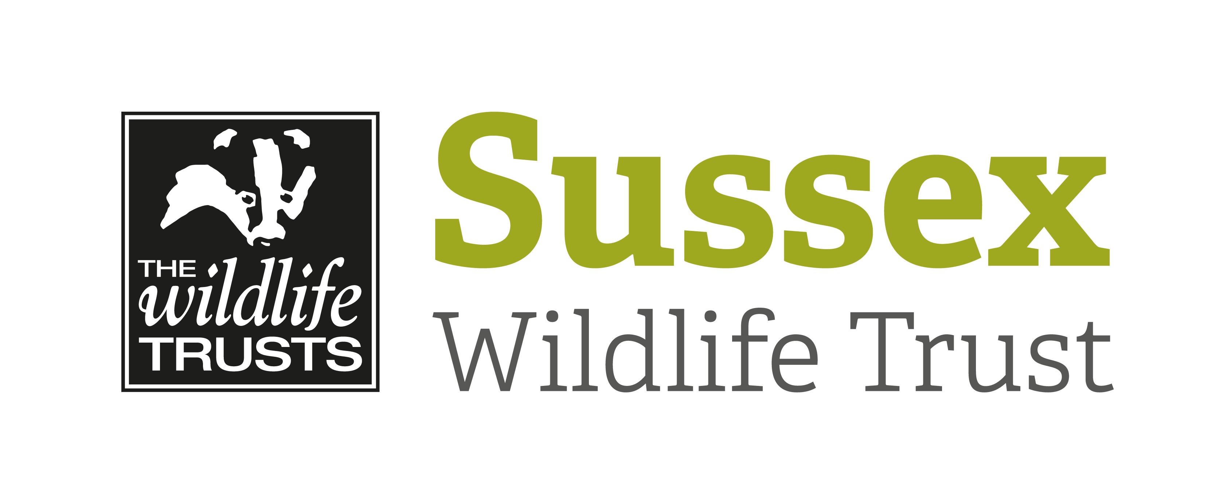

Course Title: An Introduction to Molluscs |  |  | Day/Date/Year:  Friday 21 August 2020
Start Time: 10am |  | Finish Time: 4pm
Course Tutor: | Graeme Lyons
Course description and subjects covered | Molluscs are one of the most successful groups of animals on the planet and have conquered both terrestrial and aquatic habitats.  There are 99 species of land snail in Britain but, aside from the familiar Garden Snail how many could you identify? And how many slugs (approx.. 40 species) could you put a name to? And what about the other 70 species of mollusc that live underwater?  This new course, led by Sussex Wildlife Trust Senior Ecologist Graeme Lyons, will provide you with an introduction to the snails and slugs of Sussex. We will start will start with a classroom session before heading out on to the Woods Mill nature reserve to search for and identify species. We will be looking for molluscs in the woodlands and meadows and dipping for aquatic molluscs in the ponds and streams around the reserve.
Meeting point/Venue address & nearest post code | The Classroom, Woods Mill, Henfield, West Sussex, BN5 9SD
Other sites to be visited: | Woods Mill nature reserve.
What to bring: | Please bring hand lenses, sweep net and pots if you have them although some will be available to share on the day.  Lunch / drink as required.  We will be outdoors all day so please wear appropriate clothing for the weather.
Other Information: | There are public toilets on site.  Please may we ask that you take all packed lunch waste home with you.
Public Transport: | Compass Bus Service 100 passes Woods Mill. See online timetables.
Accessibility: | There is disabled access to classroom and reserve.

