COURSE INFORMATION SHEET
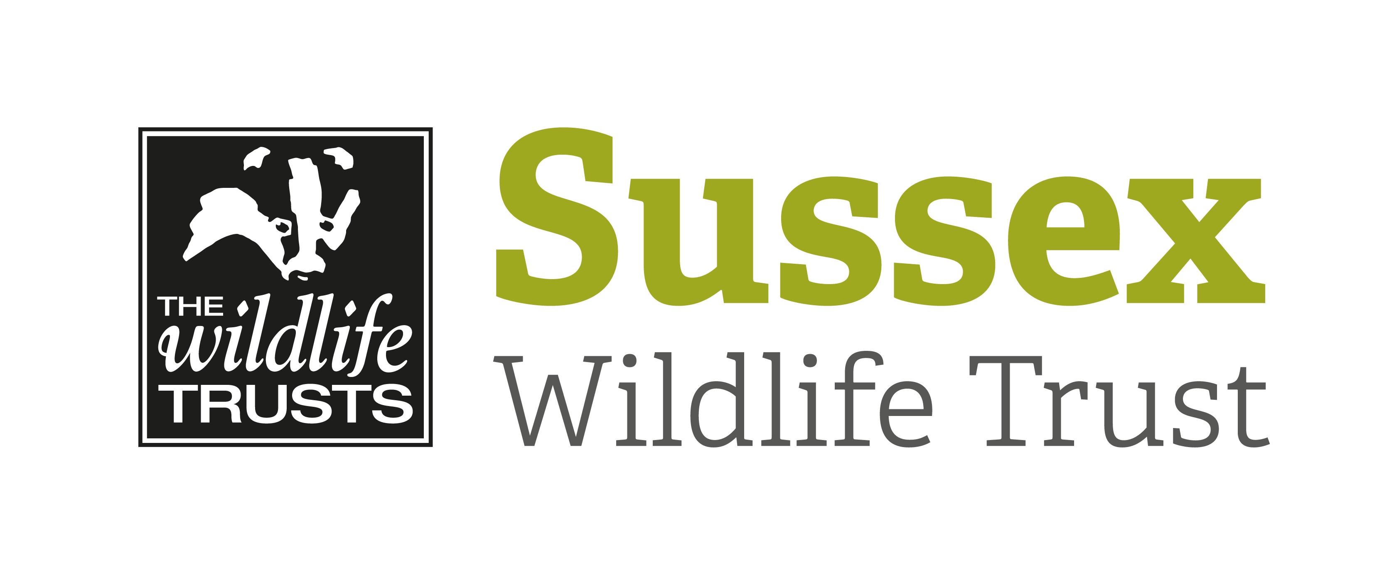

Course Title: Half Day Bird Safari – Cuckmere Haven |  |  | Day/Date/Year:  Tuesday 7 April 2020
Start Time: 9.30am |  | Finish Time: 1pm
Course Tutor: | Mike Russell
Course description and subjects covered | These special half day bird safaris are aimed at giving beginners an introduction to the bird life of Sussex in a variety of habitats.  River valleys, such as Cuckmere Haven can be important sites for migrating birds – chanelling our migrating birds into England while also providing a crucial refuelling station for hungry migrants. We’ll be scanning the wet meadows, exposed mud, trees and bushes to try and spot some of these birds as they return to the UK.  No previous knowledge or skills required, just enthusiasm!
Meeting point/Venue address & nearest post code | Seven Sisters Country Park is situated at Exceat, near Seaford, East Sussex, BN25 4AD. We will meet in the car park adjoining the A259 (near the café and visitors centre).  There is a car parking charge of £4.00 for the day (as of Sep 2019) Correct change is needed.
Other sites to be visited: | Cuckmere Haven and Cuckmere Valley
What to bring: | Suitable clothing and footwear for the time of year – the paths may well be muddy.  Refreshments.  Binoculars and a telescope if you have one  A field guide might be useful though leader will have one available
Other Information: | There are toilets behind the visitors centre and also a café and local pubs for lunch if desired.
Public Transport: | There are coastal buses from Brighton – Eastbourne. They can also be accessed from rail to Seaford & Eastbourne.
Accessibility: | We will be out for about 3 hours walking on rough tracks, which may be wet and slippery after rain.

